**SELF TEST QUESTIONS**

1. Explain what a market is  
2. Define the term Demand and Describe the relationship between demand and the price  
3. List the factors other than price that can affect the level of demand  
4. Distinguish between normal and inferior goods  
5. Define the term Supply and Describe the relationship between Supply and the rice  
6. List the factors other than price that can affect the level of Supply  
7. Explain the concept of Market Equilibrium  
8. Outline how the interaction of supply and demand has on the equilibrium position  
9. Evaluate how the changes in supply and demand can affect price

**KEYWORDS**

**Market** - This is a place where goods and service are bought and sold (Final Market)

**Final market** - This is a market – it is the last place where goods and services can be bought

**Factor Market** - This is where the factors of production can be bought and sold – Property

**Commodities** - This is a market for the sale of raw materials used

in production of goods can be bought and sold – Gold, Silver,

Copper

**Law of Diminishing Demand** - This is the satisfaction that a

consumer gets from a product or service will decrease over time

**Demand** - This is the quantity of a product that consumer will buy

at the. It is the price they will buy.

**Inflation** - This is the increase in the price of goods and service

over a period of time. It is measured by the Consumer Price

Index (CPI)

**Demand Schedule** - This shows the number of goods demanded by

the consumer at different prices

**Demand Curve** - This is the curve you get when you plot the

information form the demand schedule. It illustrates the

expected demand for a product at various levels

**Supply** - This is the quantity of a product that producers will sell

at. It is the price they will sell.

**Supply Schedule** - This shows how much the firm is willing to

supply at particular prices

**Supply Curve** - This is the curve you get when you plot the

information form the Supply schedule. It illustrates the quantity

of a product that a seller is willing to supply at different prices

**Commodity -** this refers to a raw material or agricultural product

that can be bought and sold

**Quota** - This is a limit on the number of goods made available for

sale – The number of fish you can catch

**Equilibrium** - This is the balance between the demand and supply

curve. It is the point at which the supply and demand intercept.

Both are the same price

**DEMAND CURVE**

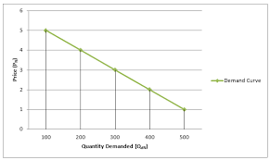

**DEMAND SCHEDULE**

|  |  |
| --- | --- |
| **Price** | **Quantity demand** |
| 1 | 500 |
| 2 | 400 |
| 3 | 300 |
| 4 | 200 |
| 5 | 100 |

**DEMAND**

Demand will increase when the price is reduced

Demand will decrease when the price increase

**FACTORS AFFECTING DEMAND**

1. Price of substitute products

2. Price of complementary goods

3. Fads and Fashion

4. Advertising

5. Change in market size

6. Seasonal factors

7. Price expectation of buyers

8. Income Levels

**SUPPLY SCHEDULE**

|  |  |
| --- | --- |
| **Price** | **Quantity demand** |
| 4 | 3 |
| 6 | 6 |
| 8 | 9 |
| 10 | 12 |

**SUPPLY**

Supply will increase when the price is increased

Supply will decrease when the price decreases

**FACTORS AFFECTING DEMAND**

1. Environment factors

2. The Price of Related Goods

3. Production and development costs

4. Technology

5. The number of Suppliers

6. Expected sellers

7. Government Intervention

**SUPPLY CURVE**

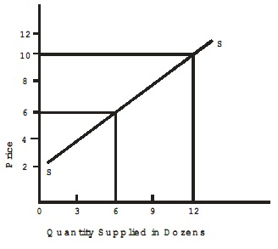

**EQUILIBRIUM**

