**KEYWORDS**

**Business Plan** - This is a plan given to a financial institution when a

business is looking for a loan

**SMART** – Specific, Measurable, Agreed/Achievable, Realistic and

Timed

**SWOT Analysis** - This identifies the Strengths, Weakness,

Opportunities and Treats of a Business

**Business Plan** - This is a written document explain what the

business does, how they do it and where they are going

**SELF TEST QUESTIONS**

1. Define the term SWOT Analysis

_______________________________________________________________________________________

_______________________________________________________________________________________  
2. Conduct a SWOT Analysis

_______________________________________________________________________________________

_______________________________________________________________________________________

4. Identify the main heading s in a Business Plan

_______________________________________________________________________________________

_______________________________________________________________________________________

5. Describe how to fill in a Business Plan

_______________________________________________________________________________________

_______________________________________________________________________________________

**USES OF A BUSINESS PLAN**

A bank will look for a business plan for the following reasons

1. The history of the business
2. Where the business gets their income from
3. What the business does
4. Will they be able to pay the loan back Consumer

**BUSINESS PLAN HEADINGS**

**SWOT ANALYSIS**

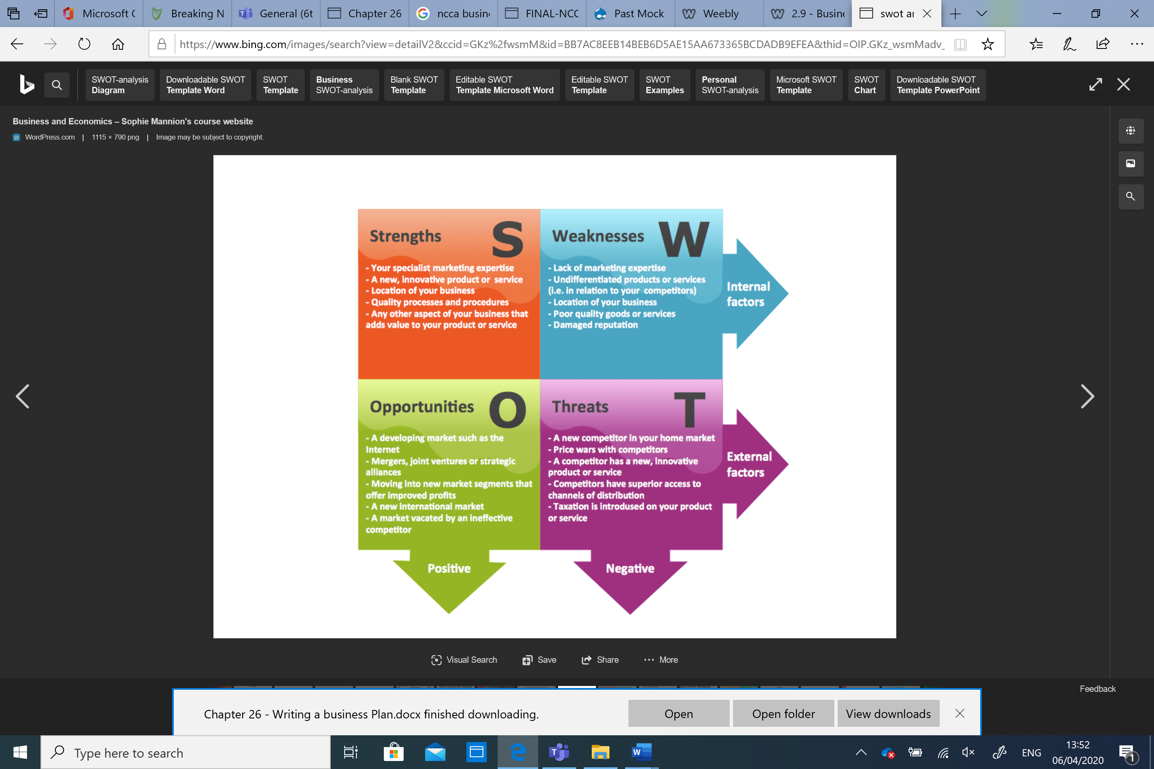

**HOW A BUSINESS SHOULD PLAN**

When setting plan the business should make them SMART.

**S** – Specific The goal should be clear

**M** – Measurable must know when the goal has been achieved

**A** – Achievable The business must be able to reach the goal

**R** – Relevant The goal must be worthwhile for the business

**T** – Timed must be a target date to achieve the goal