**SELF TEST QUESTIONS**

1. Define the term marketing and target market

_______________________________________________________________________________________  
2. List the different types of market segmentation strategies

_______________________________________________________________________________________

3. Create a marketing mix for a product of your choice

_______________________________________________________________________________________

4. Draw and Label the product life cycle

5. Explain a range of pricing strategies

_______________________________________________________________________________________

6. Describe the different promotional mix

_______________________________________________________________________________________

7. Identifying the different types of advertising

_______________________________________________________________________________________

**KEYWORDS**

**Marketing -** This is the process of identifying and satisfying

customer needs and wants while making a profit

**Market Research -** This is used to gather information about the

consumer needs and ants. There are 2 types – Desk and Field

**Marketing Segmentation -** This is when a business divides it

market into different parts (segments). This means that they can

target each of these parts meeting the customers’ needs and

wants

**Target Market -** These are the customers in a market that the

business is hoping will buy their product or services

**Marketing Mix -** This is also known as the 4ps of marketing. It is

made up of the product, price place and promotion

**Product -** This is the item that the business is selling to meet the needs of the consumer

**Brand -** This is a logo name or symbol that makes a product stand

out from its competitors and easy to recognise by the consumer

**Unique Selling Point -** This is what makes you product/service

different from the competition. It is what makes your

product/service stand out from what is already on the market

**Place** - This is where the customer will buy the product and how

the business will get it to that location

**Channels of distribution** - This s how the product will get form

the manufacture to the consumer

**Promotion -** This is how a business informs customer about their

product. This will help to increase sales and brand recognition.

**Promotional Mix** - this is the use of different promotional

activities to inform customer about their product

**FEATURES OF A PRODUCT**

1. Improving the existing product

2. Changing the price of the product

3. Selling the product in new markets

4. Promoting the product again launce an advertising campaign

**FEATURES OF A PRODUCT**

1. **Design** - This is how the product will look like, how it feels and used to attract the consumer to buy it

2. **Product life cycle** - This made up of – Introduction, Growth, Maturity Saturation and Decline

3**. Branding** - This is a logo name or symbol that makes a product stand out from its competitors and easy to recognise by the consumer.

4. **Unique Selling Point** - This is what

makes you product/service different

from the competition. It is what makes

your product/service stand out

**PRODUCT LIFE CYCLE**

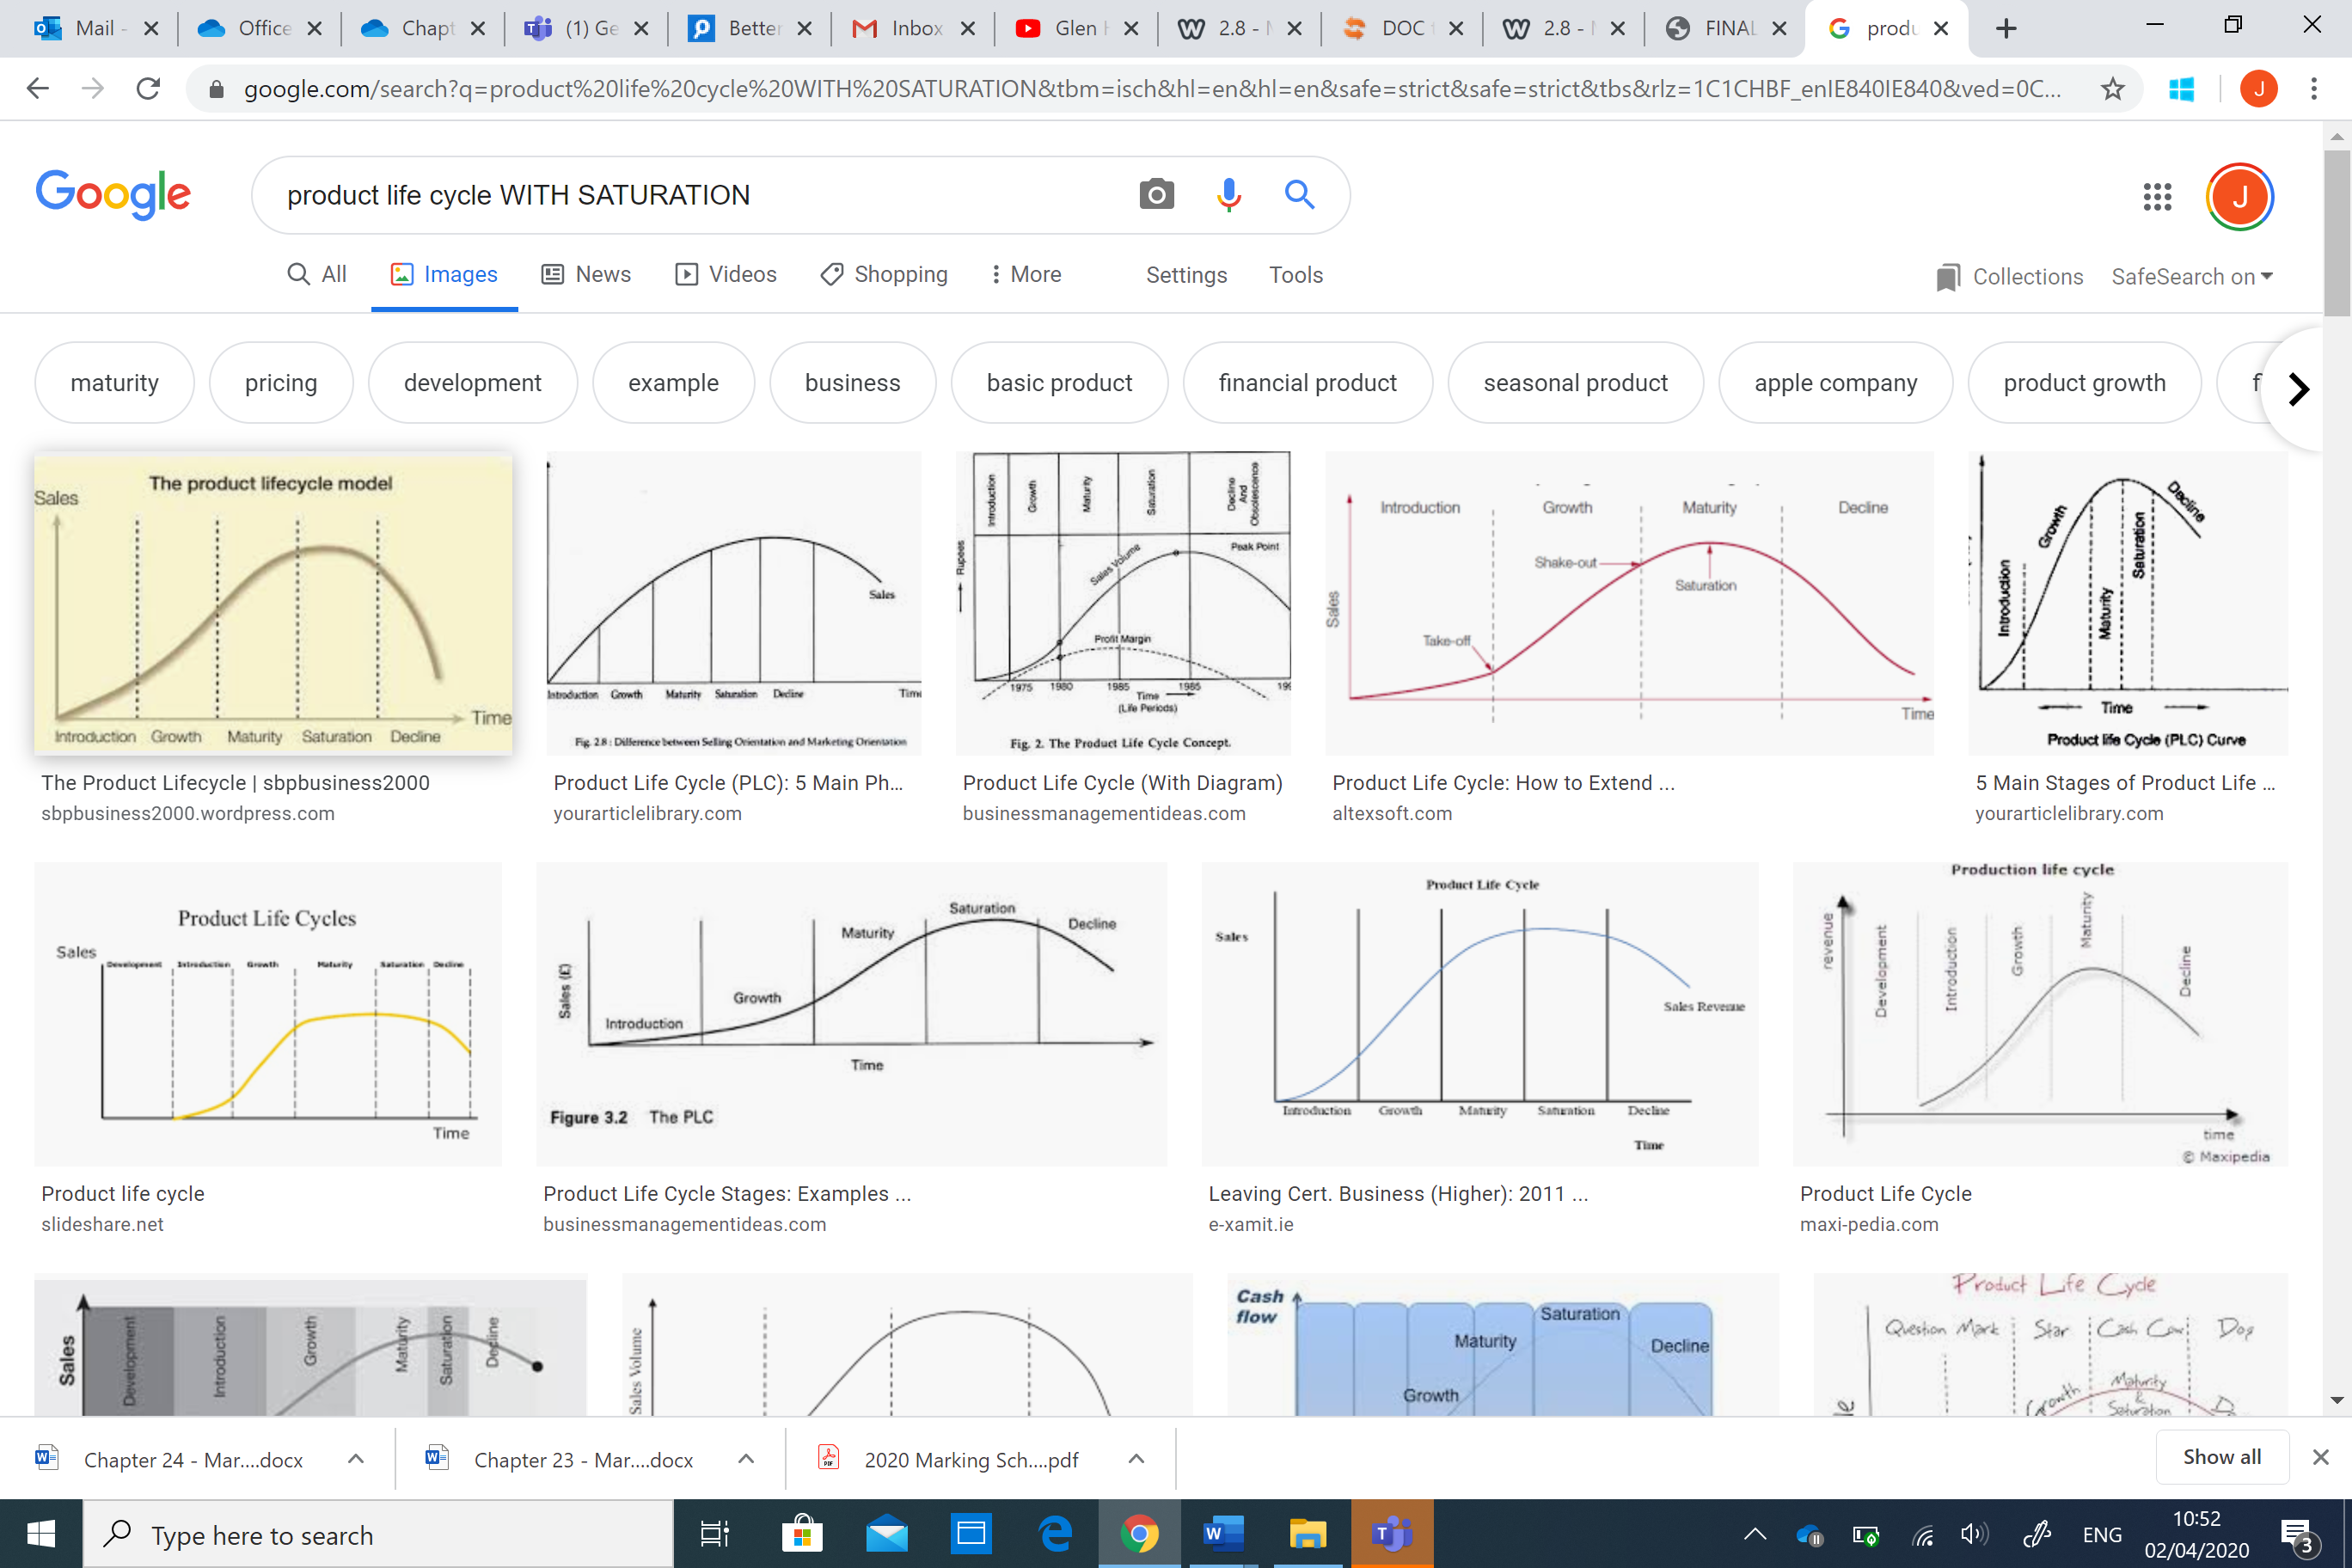

**FACTORS IN SETTING A PRICE**

1. The cost of making the product

2. The profits the business wants to make

3. The stage the product is at I the product life cycle

4.What are competitors charging for the product

5. Who is our target market?

**PLACE**

*Channel A (Corner Shop)*

Manufacture Wholesaler Retailer Consumer

*Channel B (Argos)*

Manufacture Wholesaler Consumer

*Channel C (Supermarkets)*

Manufacture Retailer Consumer

*Channel D (Online Shopping)*

Manufacture Consumer

**PRICING**

|  |  |  |  |  |
| --- | --- | --- | --- | --- |
| **Premium Pricing** | **Penetration Pricing** | **Loss Leaders** | **Discriminatory Pricing** | **Cost Plus** |
| Charge a high price for their product | Charge a low price at first to enter the market | A business will sell a product at a loss | Charging people different prices for the same product | The business adds a percentage to the cost price |
| This gives the product a sense of status and quality | Once the product is known it will increase the price | This attract customer into the business and buy goods at a higher price | Large number of people can be observed. It is also cheap | This is the profit they would like to make |
| Hugo Boss | Fulfill (New bar) | Petrol Stations | Cinema Tickets |  |

**HOW TO SELECT A CHANNEL OF DISTRUBUTION**

1. The product – how long will the product last – fruit and veg needs to be delivery quickly else it will go off

2. Legal requirements – You have to sell certain products in shop and not over the internet. Medicines

3. Image – Some business will only want here product sold in certain shops. This will bring a positive image to the product. Brown Thomas

**ADVERTISING**

**Advertising** - This is communicating with the public to let

them know about a product and to get them to buy it

**Informative advertising** - This is information the public

about the product. It provides information about the product

to potential customers

**Persuasive advertising** - This tries to get the customer to

buy the product. It gets

them to believe that they need the product

**Competitive advertising** - This is when the business tells

customer that there product is better form the competition

**Reminder Advertising** - This is used to remind customer that

the product is still available. It is used towards the end of

the product life cycle to try and increase sales

**Generic advertising** - Business in the same industry come

together to try a persuade customer to buy a particular type

of product for example an Bord Bia – pork products

**ADVERTISING**

**Advertising** - This is communicating with the public to let

them know about a product and to get them to buy it

**Informative advertising** - This is information the public

about the product. It provides information about the product

to potential customers

**Persuasive advertising** - This tries to get the customer to

buy the product. It gets

them to believe that they need the product

**Competitive advertising** - This is when the business tells

customer that there product is better form the competition

**Reminder Advertising** - This is used to remind customer that

the product is still available. It is used towards the end of

the product life cycle to try and increase sales

**Generic advertising** - Business in the same industry come

together to try a persuade customer to buy a particular type

of product for example an Bord Bia – pork products

**PROMOTION**